Review Comment: Backend compilation error is not fixed.

It was already fixed. There is no error message during Build, scan or test in backend in Main and feature branch.

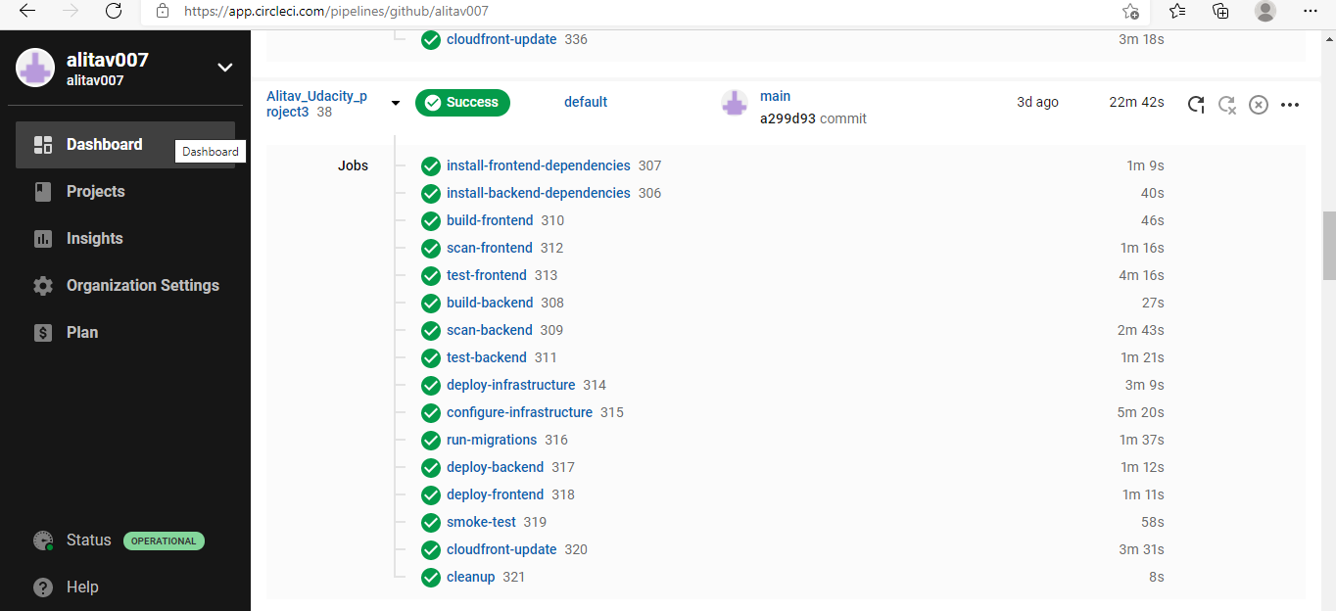

Back end Unit not fixed.

It was already fixed. There is no error message during Bulid in Main and feature branch.

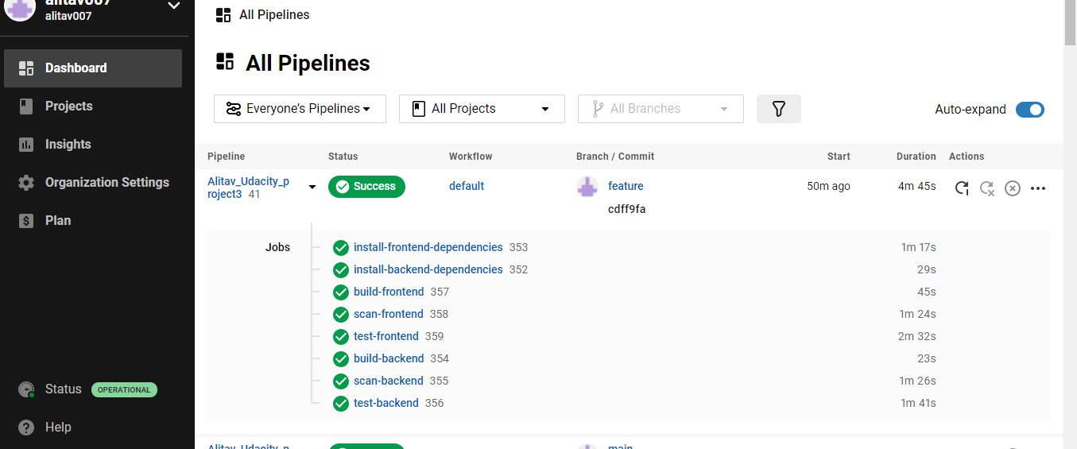

Review comment:

 Please create the branch filters and provide the screenshot of the build of a non-master branch. Now, you will deploy the infrastructure when the branch is not master

Please refer screenshot.



Your backend app is not accessible:

All my backend build,deploy,etc completed successfully and my instances are up and running. I’m really don’t understand why it is not coming up.

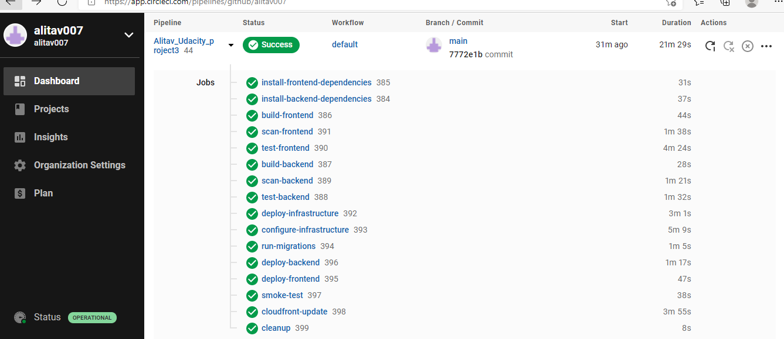

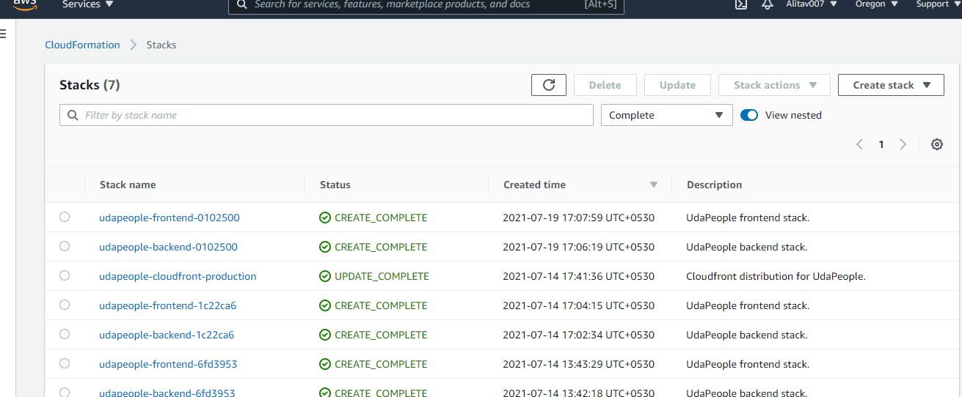

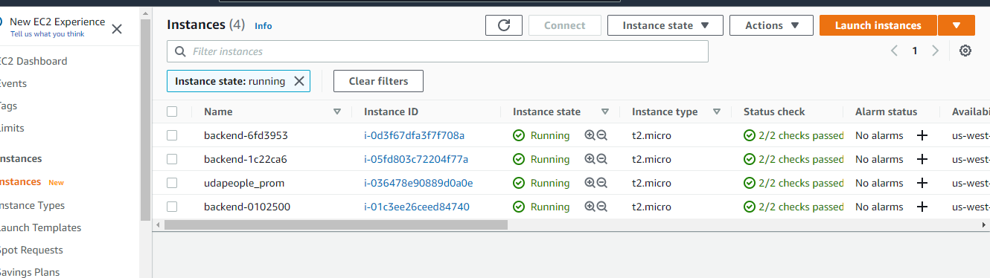

Services are not correctly discovered:

All my instances are up and running and I don’t have any idea why it is showing as DOWN.

